URL: https://adityabirlahospital.com/doctors/cardiologist-in-pune

Meta Title: Best Cardiologist | Heart Specialist In Pimpri Chinchwad, Pune

Meta Descriptions: Find the best cardiologist in Pimpri Chinchwad at Aditya Birla Hospital. Expert heart care and advanced treatments for all cardiac conditions. Book now!

Best Cardiologist in Pimpri-Chinchwad Pune
Cardiologists are specialized medical professionals dedicated to diagnosing and treating conditions of the heart and cardiovascular system. These heart doctors manage heart diseases and offer preventive care, safeguarding your heart health and supporting long-term wellness.

Our Team Of Cardiology Doctors
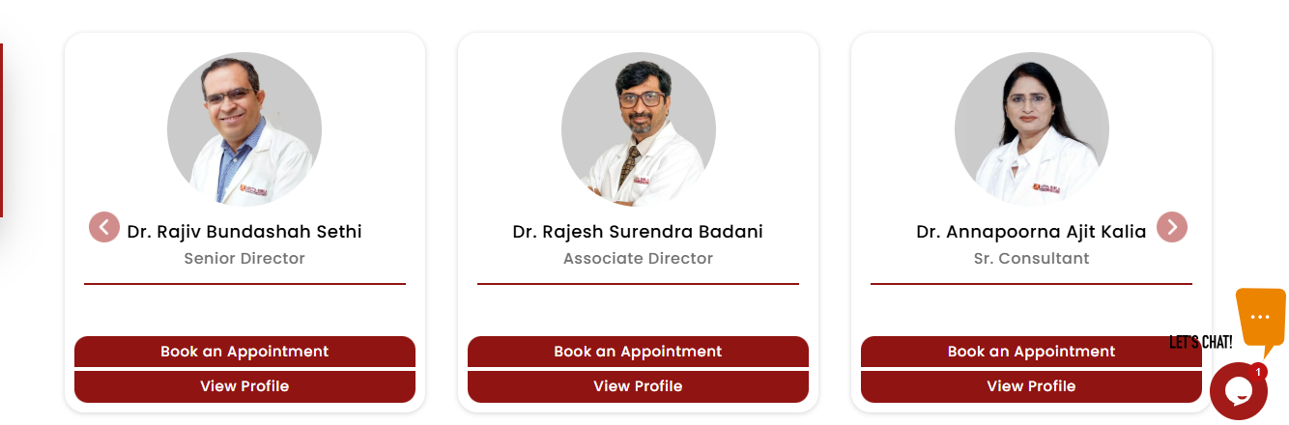

Choosing Aditya Birla Memorial Hospital, a leading Cardiology Hospital in Pimpri Chinchwad Pune, for your heart care means more than just access to highly skilled cardiac specialists. We offer a comprehensive range of cardiac services, including advanced procedures and cutting-edge technology, ensuring you receive exceptional care for all your heart-related concerns.
At our hospital, you benefit from the expertise of some of the best heart specialists and cardiac surgeons in Pimpri, Pune, along with the tools and knowledge you need to maintain a healthy heart. Our goal is to help you lead a vibrant, fulfilling life by prioritizing your heart health.
For expert cardiac care that places your well-being at the forefront, visit Aditya Birla Memorial Hospital and experience the compassionate, patient-centered approach of our cardiology team.

Our Cardiologists Treat the Following

Conditions:
- Coronary Artery Disease (CAD)
  - Angioplasty and stent placement to open blocked arteries
  - Treatment of heart attacks
  - Coronary artery bypass grafting (CABG) for blocked arteries
- Peripheral Artery Disease (PAD)
  - Balloon angioplasty and stenting for leg artery blockages
- Heart Valve Disease
  - Transcatheter aortic valve replacement (TAVR)
  - Balloon valvuloplasty for valve stenosis
  - Valve repair or replacement surgeries (e.g., mitral and aortic valves)
- Congenital Heart Defects
  - Non-surgical repair of septal defects (ASD, VSD)
  - Surgical correction of defects such as atrial septal defect (ASD) and ventricular septal defect (VSD) in children and adults
- Arrhythmias
  - Electrophysiology studies and ablation for rhythm correction
- Chronic Total Occlusions (CTO)
  - Advanced techniques to open long-standing blocked arteries
- Lung and Thoracic Conditions
  - Surgical treatments for lung cancer, mediastinal tumours, and other thoracic diseases
- Heart Failure
  - Surgical options for advanced heart failure, including ventricular assist devices (VADs) and heart transplantation

How Do I Find a Heart Doctor Near Me in Pune?

If you are looking for the best cardiology specialists near you in the PCMC area, you can reach us easily from many areas nearby.

Nearby Locations:

Hinjewadi, Wakad, Baner, Aundh, Pimple Saudagar, Bhosari, Ravet, Chinchwad Gaon, Tathawade, Nigdi, PCMC, Pimpri, Moshi, and Chakan

